HIS 3341: The French Revolution and Napoleon
Summer II (2017) – Online

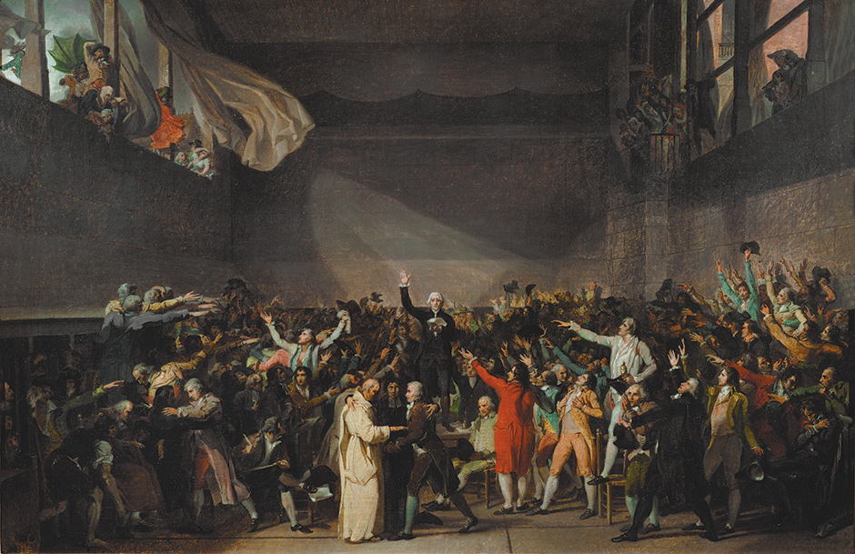

Course Description: This course will treat the history of the French Revolution from the mid-18th century through the rise and fall of Napoleon. Material in the course will address varied interpretations of the revolution from classical Marxist to more recent cultural, feminist, and post-modern, and imperial perspectives on the subject. We will also devote significant discussion to the imperial and international dynamics of the Revolution, particularly dealing with the Haitian Revolution (1793-1801). In addition to various texts on France and the Revolution itself, the course also includes a detailed discussion of Napoleon Bonaparte's military and political career with due consideration given to the resulting Bourbon Restoration and its impact on the subsequent political configuration of 19th century Europe.

Online Format: This course will be conducted entirely online through email (tuc70342@temple.edu), Blackboard (https://blackboard.temple.edu/) and WebEx (https://webex.temple.edu/). You will be assigned weekly readings from the textbook as well as a set of questions tailored to those readings. Every week, you must complete the readings and questions and email me your answers (saved on a Word document) by Sunday evening at midnight. Each week, I will also host one online discussion (roughly 1 hour in length) and will provide you all with a topic or theme ahead of time to guide these meetings. These discussions will operate through WebEx, and participation requires access to a computer, the internet, a webcam, and a microphone. I will also offer weekly discussion topics (through Blackboard's Discussion Board) for those unable to logon to the WebEx sessions. The research paper prompt will be posted to Blackboard or discussed in a WebEx session during week 3, and you will turn the final paper in via email by no later than Saturday, August 1. For more on the breakdown of these components, see Assignments section below.

Instructor: David A. Guba, Jr.
Email: tuc70342@temple.edu
Ph: 304-479-2520
Office: Gladfelter 953
Office Hours: T&R, 1:00PM-2:00PM or by appointment
Main Texts:
- Georges Lefebvre, The Coming of the French Revolution (Princeton: Princeton University Press, 2015)
- Peter McPhee, The French Revolution, 1789-1799 (New York: Oxford University Press, 2002).
- Jeremy Popkin, A Short History of the French Revolution (Prentice Hall, 2010).
- David A. Bell, Napoleon: A Concise Biography (Oxford University Press, 2015).
- Laurent Dubois, Avengers of the New World: The Story of the Haitian Revolution (Cambridge: The Belknap Press of Harvard University Press, 2004).
- C.L.R. James, Black Jacobins: Toussaint L’Ouverture and the San Domingo Revolution (London: Secker & Warburg, 1938)
Useful Websites: Throughout the semester, we will read several primary sources from French history. Most of these sources will be available online through one of the following digital archives:

Florida State University http://guides.lib.fsu.edu/content.php?pid=47973&sid=1180775

UCLA French Studies http://guides.library.ucla.edu/c.php?g=180228

Fordham IHSB http://legacy.fordham.edu/Halsall/mod/modsbook13.asp

Assignments:
- Readings and Reading Questions: Each Week, you will read roughly 120 pages of excerpts from our course texts and occasionally some supplemental primary and/or secondary sources. Each week, I also will assign and post to Blackboard a set of short essay questions tailored to the week’s assigned readings. At the end of each week (Sundays) you must turn in your answers to these questions via email (tuc70342@temple.edu). The only exception is for Week 6; this question set must be turned in along with your final paper by Saturday, August 1. Be sure to answer each question sufficiently, drawing from specific examples in the assigned readings to support your answers. (6 question packets, 5 points each = 30 points)

- Online Discussions (WebEx and Blackboard) and Projects: Each week I will lead three online discussion through WebEx, the days and times of which will be determined at the beginning of the course and based on your input. These sessions (conducted through https://webex.temple.edu/) will run roughly 1 hour, and I will provide questions, topics, and/or short primary source readings to focus discussions. You will be graded based on attendance at and (more importantly) participation in these sessions. If you are unable to logon to the WebEx discussions, I will also post weekly discussion board topics on Blackboard. The topics of these Discussion Boards will match those of the WebEx sessions. And for you the Discussion Boards you must contribute at least 250 words. In total, you are responsible for attending and/or contributing to at least 6 discussions out of a possible 12. (6 discussions, 5 points each = 30 points)

- Research Paper: The paper will be roughly 2000-2500 words in length (8-10 pages) and will focus on a topic or theme from the French Revolution . I will distribute prompts on the second week of class. And you are more than welcome to come up with your own topic—just run it past me first (via email). Paper Format: Size 12, Times New Roman, 1-inch margins, Chicago Style Citations. Due via email no later than Saturday, August 1 at midnight (40 Points).

Grade Breakdown:

Reading Questions 30 Points
Discussions 30 Points
Research Paper 40 Points
Total 100

Schedule:

BB = Posted as Pdf on Course Blackboard Site

Week 1 (June 22 - June 28) – The Origins of Revolution and the Ancien Régime

Session 1: The French Revolution: History and Historiography
- McPhee - Intro and Chapters 1 & 2, pp. 1-49
- Jeremy Popkin, A Short History, Chapter 1-3
- "The Historiography of the French Revolution" http://lycfrenchrevolution.wikispaces.com/file/view/Historiography+Taylor.pdf
Session 2: The Ancien Régime
- Voltaire, “On the Church of England,” (1733) BB
- Rousseau, “The Social Contract,” (1762) BB
Session 3: Economic Origins of the French Revolution
- Georges Lefebvre, The Coming of the FR, Prologue and Part 1
- Jacques Necker, “Account to the King,” (1781) BB
- Alexis de Tocqueville, The Old Regime excerpt BB
Question Set #1: Origins of the French Revolution

Discussion Board Topic #1: Explain the origins of the French Revolution.

Week 2 (June 29 – July 5) - The French Revolutions of 1789 and 1792

Session 1: The Third Estate
- McPhee - Chapters 3,4 & 5, pp. 50-108
- Abbé Sièyes, “What is the Third Estate?” (1789) BB
Session 2: The Rights of Men (and Women?)
- Jeremy Popkin, A Short History, Chapter 1-3
- “The Declaration of the Rights of Man and Citizen,” http://avalon.law.yale.edu/18th_century/rightsof.asp
- Olympe de Gouges, "Declaration of the Rights of Women and of Citizens," http://legacy.fordham.edu/Halsall/mod/1791degouge1.asp
Session 3: The Rights of Men (and Slaves?)
- Laurent Dubois, Avengers of the New World, Intro and Ch. 1
- Tousaint’s Constituion of 1801: https://thelouvertureproject.org/index.php?titl e=Haitian_Constitution_of_1801_(English)
Question Set #2: The First Phases of the Revolution

Discussion Board Topic #2: How have historians interpreted the role of women in the French Revolution?

Week 3 (July 6 – July 12) The Terror and the Revolutionary Wars

Session 1: Max Robespierre and the Community of Public Safety
- McPhee - Chapters 6 & 7, pp. 109-153
- Robespierre and the “Cult of the Supreme Being,” (1794) http://legacy.fordham.edu/Halsall/mod/robespierre-supreme.asp
Session 2: The Revolutionary Wars
- Jeremy Popkin, A Short History, Chapter 4-6
- “The Proclamation of the Duke of Brunswick, 1792” https://history.hanover.edu/texts/bruns.html
Session 3: The Thermidorian Reaction
- Jeremy Popkin, A Short History, Chapter 6
- Robespierre, “The Virtue of Terror,” http://www.emersonkent.com/speeches/the_virtue_of_terror.htm
Question Set #3: The Radicalization and Terror of the Revolution

Discussion Board Topic #3: Writing the History of the French Revolution – Journal Assignment

Week 4 (July 13 – July 19) The End of the French Revolution and the start of the Haitian

Session 1: The Directory
- McPhee - Chapters 8-10.
- Robespierre and the “Cult of the Supreme Being,” (1794) http://legacy.fordham.edu/Halsall/mod/robespierre-supreme.asp
Session 2: The Haitian Revolution
- Laurent Dubois, Avengers of the New World, Intro and Ch. 2-4, 5.
- Excerpt from C.L.R. James Black Jacobins (1938) BB
Session 3: Toussaint Louverture and the “Double Bind” of race in Revolutionary France
- Laurent Dubois, Avengers of the New World, Intro and Ch. 6-7
- Excerpt from Frantz Fanon, Black Skin, White Masks (1953) BB
Question Set #4: The Imperial and Racial Dynamics of the French Revolution

Discussion Board Topic #4: Writing the History of the French Revolution – Narrative Assignment

Week 5 (July 20 – June 26) The Rise of Napoleon

Session 1: Napoleon: The Corsican
- David A. Bell, Napoleon, Ch. 1

Session 2: Napoleon: The Military Savant
- David A. Bell, Napoleon, Ch. 2-3
- Napoleon’s Account of his Coup d’Etat on 10 September 1799: http://www.columbia.edu/~iw6/docs/nap_coup.html
Session 3: Napoleon: The Emperor
- David A. Bell, Napoleon, Ch. 4
- Napoleon’s Farwell to the Old Guard, 1814: http://www.historyplace.com/speeches/napoleon.htm
Question Set #5: The Rise and Fall of Napoleon.

Discussion Board Topic #5: Should history portray Napoleon in a positive or negative light?

Week 6 (July 27 – Aug 1) Restoration France and the Echoes of Revolution

Session 1: The Fall of Napoleon
- David A. Bell, Napoleon, Ch. 5
- "The Battle of Waterloo as recounted by one of Napoleon's Personal Aides," (June 1815): https://chnm.gmu.edu/revolution/d/528/
- "The Burning of Moscow as Seen by One of Napoleon's Generals," https://chnm.gmu.edu/revolution/d/522/
Session 2: Restoration France
- David A. Bell, Napoleon, Epilogue
- Napoleon’s Account of his Coup d’Etat on 10 September 1799: http://www.columbia.edu/~iw6/docs/nap_coup.html
Session 3: The End of the French Revolution
- Francois Furet, Interpreting the French Revolution, excerpt on BB
Question Set #6: Restoration France

Discussion Board Topic #6: Do you agree or disagree with Furet’s contention that “The French Revolution is over?”

*Final Paper and Week 6 Question Set due: Saturday Aug 1

