HIS 0874, Section 2
Confronting Empire
Fall 2013
TR: 3:30PM-4:50PM, Anderson 208

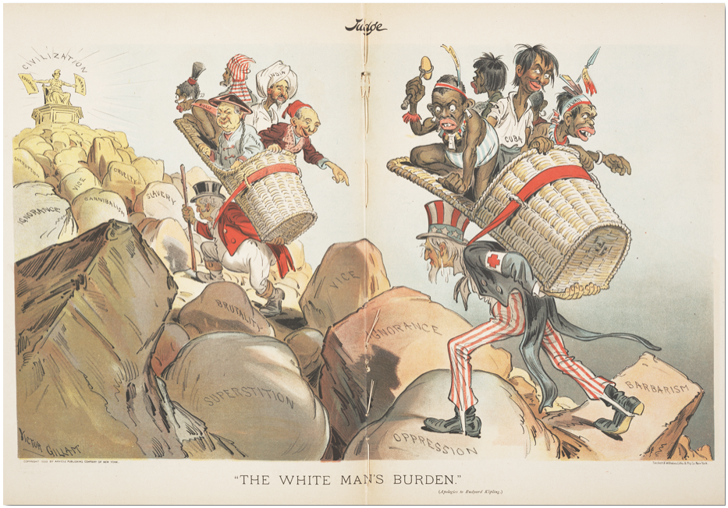

[Note: This course fulfills the General Education World Societies (GG) requirement OR the “IS” requirement under the old Core Curriculum. 3 credit hours.]

Instructor: David A. Guba, Jr.
Email: tuc70342@temple.edu
Ph: 304-479-2520
Office: Gladfelter 953
Office Hours: T&R, 1:00PM-2:00PM or by appointment

Course Description: This course examines the origins, dynamics, and repercussions of “new” imperialism in world history. Starting in the mid-to-late 19th century, imperial nation-states across the globe scrambled to acquire and control as much overseas territory as possible, and largely in the undeveloped but resource-rich areas of Latin America, Africa, and Asia. Though dominant societies in Europe, the Americas, and Asia had pursued empire-building for centuries, the economic, political, intellectual, technological, and cultural transformations of the 19th century produced an unprecedented fervor for imperial expansion that worked to shape the rocky landscape of 20th century world history as well as the world we live in today. In the first unit of the course, we will examine the origins and dynamics of “new” imperialism. Why did most powerful states—whether republics or monarchies, dictatorships or communes—engage in the project of new imperialism in the late 19th and early 20th centuries? What drove this unprecedented and global conquest of territory? What impact did this new phase of imperialism have on both colonizers and the colonized? And what enabled and facilitated this conquest? Our readings and class meetings during the first unit will work to answer and complicate these and related questions.

In the second half of the course, we will concentrate on the “end” and lasting echoes of new imperialism during the mid-to-late 20th century and the ways in which empire continued (and continues) to shape the political, social, economic, and cultural landscapes of both metropoles and their former colonies long after formal decolonization. Between the end of the Second World War and the early 1960s, roughly 3 dozen new states in Asia, Latin America, and Africa gained independence from their colonial rulers. From 1961 to 1975, another 2 dozen states in Africa alone achieved autonomy from their Western colonizers. This rapid proliferation of nation-states in the Third World and simultaneous deflation of Western empire drastically transformed the direction of world history. What led to and facilitated this collapse of new imperialism? How did the colonized achieve independence from their colonizers? Was decolonization a success of failure for liberated nation-states, or for former colonizers? And did this phase of decolonization really bring an end to empire? These and related questions will guide us through the second unit.

Books:

J.H. Elliot, Empires of the Atlantic World: Britain and Spain in America, 1492-1830. Yale
University Press, 2005.

Michel-Rolph Trouillot, Silencing the Past: Power and the Production of History. Beacon Press,
1995.

H.L. Wesseling, Divide and Rule: The Partition of Africa, 1880-1914. Praeger, 1996.

Mark Mazower, Hitler’s Empire: Nazi Rule in Occupied Europe. Penguin, 2013.

Odd Arne Westad, The Global Cold War: Third World Interventions and the Making of Our Times.
Cambridge University Press, 2007.

Judith Surkis, Sexing the Citizen: Morality and Masculinity in France, 1870-1920. Cornell UP,
2018.

Todd Shepard, The Invention of Decolonization: The Algerian War and the Remaking of France.
Cornell University Press, 2008.

Phillip Gourevitch, We Wish to Inform You That Tomorrow We Will be Killed… Picador, 1999.

Assignments: Students are expected to attend all classes, complete all readings, hand in all assignments on time, and participate in discussions regularly. Frequent absences, late arrivals, or early departures and failures to complete all assignments may result in a failing grade for the entire course.

- Attendance &Participation: Active participation is the key to a high grade in the course. It not only means regularly attending class but also coming prepared and contributing to discussion. Your participation grade will be determined by the quality and quantity of your contributions. (20 points)
- 6 quizzes: Throughout the semester you will be given a question related to that particular week’s assigned readings. You will have 10 minutes to write a response to the question and the quiz is open-note. Your answer will be graded on the level of detail, the quality of your response, and your ability to link the readings to broader themes discussed in class that week. There will be 6 quizzes during the semester, and the lowest grade of the 6 will be dropped. (5 quizzes, 5 points each)
- Midterm: You will be given a mid-term exam (October 10). This exam will take roughly an hour to complete and will consist of ID’s, short answers, and an essay question. (25 points)
- Final Writing Assignment: During the semester you will complete one major (1500-2000 words) writing assignment. In this paper, you must articulate a thesis and support your argument in a well-structured, analytical composition that pulls evidence (sources) from course readings, lectures, and outside research. I will distribute essay questions four weeks before the due-date (TBD). (30 points)

Grade Distribution:

20% Att. & Participation
25% Quizzes
25% Midterm
30% Final Paper
100%

Learning Outcomes: The objective of the course is to provide you with an understanding of the historical foundations of new imperialism in the nineteenth and twentieth centuries. By the end of the semester, you will be able to:
- Understand key political concepts like colonialism, nationalism, fascism, liberalism, communism, imperialism, and globalization within their historical context.
- Understand the major political, economic, and cultural transformations of the last two centuries
- Work with primary sources and place them within their historical context.
- Understand and evaluate interpretations of secondary sources.
- Identify and participate in historical debates about key historical transformations such as imperialism, colonialism, the origins of the two world wars, decolonization, and the cold war.
- Develop independent arguments about central historical questions.
- Connect past developments to current global trends.
- Identify key changes in the political world map over the past two centuries.
Disability Statement: Any student who has a need for accommodation based on the impact of a disability should contact me privately to discuss the specific situation as soon as possible. Contact Disability Resources and Services at 215-204-1280 in 100 Ritter Annex to coordinate reasonable accommodations for students with documented disabilities.
Academic Freedom: Freedom to teach and freedom to learn are inseparable facets of academic freedom. The University has adopted a policy on Student and Faculty Academic Rights and Responsibilities (Policy # 03.70.02) which can be accessed through the following link: http://policies.temple.edu/getdoc.asp?policy_no=03.70.02>.

Unit 1: Old and New Imperialisms

Week #1 Aug. 27 Introduction

Aug. 29 God, Gold, and Glory
Readings: Elliot, The Empires of the Atlantic World (excerpts)

Week #2 Sept. 3 New Imperialism
Readings: J.A. Hobson, “Imperialism: a Study,” in Harrison M. Wright, The New Imperialism, Preface, Introduction, The Economics of Imperialism: http://www.marxists.org/archive/hobson/1902/imperialism/

Sept. 5 Civilization and Power
Readings: Trouillot, Michel-Rolph, “Good Day Columbus: Silences,
Power, and Public History,” Public Culture 3:1 (Fall, 1990):1-24;
Excerpts from M. R.-T. Silencing the Past

Week #3 Sept. 10 Social Darwinism & the Civilizing Mission – Britain & France
Readings: Kipling, “White Man’s Burden,”
http://www.fordham.edu/halsall/mod/kipling.asp;
Jules Ferry (1832-1893): “On French Colonial Expansion,”
http://www.fordham.edu/halsall/mod/1884ferry.asp

Sept. 12 The Belgian Congo
Readings: Wessling, Divide and Rule (excerpt/handout)

Week #4 Sept. 17 German East Africa
Readings: Friedrich Fabri, Does Germany Need Colonies? (1879): germanhistorydocs.ghi-dc.org/sub_document.cfm?document_id=1867; Society for German Colonization, Founding Manifesto (March1885):
germanhistorydocs.ghi-dc.org/sub_document.cfm?document_id=667; Kaiser Wilhelm II: A Place in the Sun (1901): http://www.fordham.edu/Halsall/mod/1901Kaiser.asp

Sept. 19 The American Empire I
Readings: Thomas Jefferson, “Empire of Liberty,” (excerpt); Beveridge, “In Support of an American Empire,” (1900):
https://www.mtholyoke.edu/acad/intrel/ajb72.htm

Week #5 Sept. 24 The American Empire II
Readings: American Anti-Imperialist League, Platform (1899):
http://www.fordham.edu/halsall/mod/1899antiimp.asp; Mark Twain, Writings against American Empire:
http://www.loc.gov/rr/hispanic/1898/twain.html

Sept. 26 Movie: Quemada
Readings: none

Week #6 Oct. 1 WWI and New Imperialism
Readings: W.E.B. Dubois, “The African Roots of
War” (1915)
http://www.library.umass.edu/spcoll/digital/dubois/WarRoots.pdf;

Oct. 3 Contested Hegemony
Readings: Adas, Michael. “Contested Hegemony.” Journal of World
History 15:1 (March 2004): 31-63. (Jstor)

Week #7 Oct. 8 Midterm

Unit 2: The End of Empire?

Week #7 Oct. 10 Interwar Imperialism I
Readings: Article 22 of the League of Nations Covenant - Mandate System: http://avalon.law.yale.edu/20th_century/leagcov.asp#art22;

Week #8 Oct. 15 Interwar Imperialism II Readings: Mazower, Hitler’s Empire (excerpt/handout)

Oct. 17 WWII and Alternative Visions of
Civilization
Readings: Aimé Césaire, Discourse on Colonialism (1955): http://www.rlwclarke.net/Theory/SourcesPrimary/CesaireDiscourseonColonialism.pdf;Jawaharlal Nehru, “Speech at Bandung Conference (1955)

Week #9 Oct. 22 Gandhi & India’s Independence
Readings: Gandhi: "Non-Violence Is the First Article of My Faith" (handout)
Oct. 24 Ho Chi Mihn& Decolonization in
Vietnam
Readings: Ho Chi Minh, “Vietnamese Declaration of Independence (1945)

Week #10 Oct. 29 Fanon & the End of French
Empire
Readings: Frantz Fanon, “Concerning Violence” (1961) Todd Shepard, The Invention of Decolonization (excerpt); Todd Shepard, Sex, France, Arab Men (excerpts); Judith Surkis, Sexing the Citizen (excerpts)

Oct. 31 Movie: Battle of Algiers

Week #11 Nov. 5 Decolonization and Liberation
Readings: Eric Wolf, Europe and the People Without History, 2nd ed. (California, 2010), ix-23. Forward, Prefaces, and Introduction: http://www.ucpress.edu/book.php?isbn=9780520268180;

Nov. 7 Decolonization in the United States
Readings: Port Huron Statement (1961): http://coursesa.matrix.msu.edu/~hst306/documents/huron.html; Robert Blauner, “Internal Colonialism and Ghetto Revolt,”Social Problems 16:4 (Spring, 1969):
http://socrates.berkeley.edu/~tochtli/blackstudies129/Blauner.pdf; M.L. King, “Why I am Opposed to the Vietnam War” (1967).

Week #12 Nov. 12 America’s Informal Empire during the Cold War
Readings: Odd Arne Westad, The Global Cold War, 1-38 (handout)

Nov. 14 (Post)colonialism
Readings: Ashcroft, et al. The Post-Colonial Studies Reader, Introduction (handout); Paulo Freire, The Pedagogy of Oppression (excerpts); Dipesh Chakrabarty, “Postcoloniality and the Artifice of History,” in The Post- Colonial Studies Reader (handout)
*Paper #2 Due

Week #13 Nov. 19 Lasting Echoes of Imperialism I
Readings: Gourevitch, We Wish to Inform You, Part 1

Nov. 21 Lasting Echoes of Imperialism II
Readings: Gourevitch, We Wish to Inform You, Part II

Week #14 Nov. 26 Movie: Hotel Rwanda

Week #15 Dec. 3 Neo-Imperialism &Globalization
Readings:Frederick Cooper, Colonialism in Question: Theory, Knowledge, History, Chapter 4, “Globalization,” (Berkeley, Calif.: University of California Press, 2005) (handout); Hopkins, Anthony. “Lessons of Civilizing Missions Are Mostly Unlearned,” New York Times (March 23 2003): http://www.nytimes.com/2003/03/23/weekinreview/lessons-of-civilizing- missions-are-mostly-unlearned.html;
Dec. 5 Wrap-Up

Final Paper: Wednesday, December 11 by midnight (emailed to me)

